Touching Collinear Segments

Definition
# Source: AI Source: Provided by: [Data Path: Persons Table -> ID Column: 1, Name_En Column: Motasem Essam] -> From: [ChatGPT] on [7/25/2026]
Touching Collinear Segments are two or more line segments that:
- lie on the same supporting straight line, and
- meet at one or more boundary points without sharing a positive-length portion.
For the standard two-segment case, the segments meet at exactly one common endpoint.
For example:
A ●────────● B=C────────● D
The segments $\overset{‾}{AB}$and $\overset{‾}{CD}$are collinear and touch at the common endpoint $B=C$.
Mathematically:
$$\overset{‾}{AB}⊆l \\ \overset{‾}{CD}⊆l$$
and:
$$\overset{‾}{AB}∩\overset{‾}{CD}=\left\{B\right\}$$
Therefore, their minimum separation is:
$$\boxed{g=0}$$
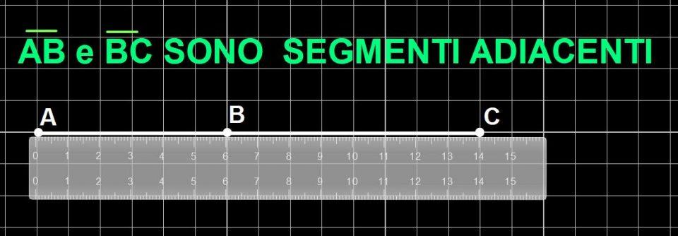
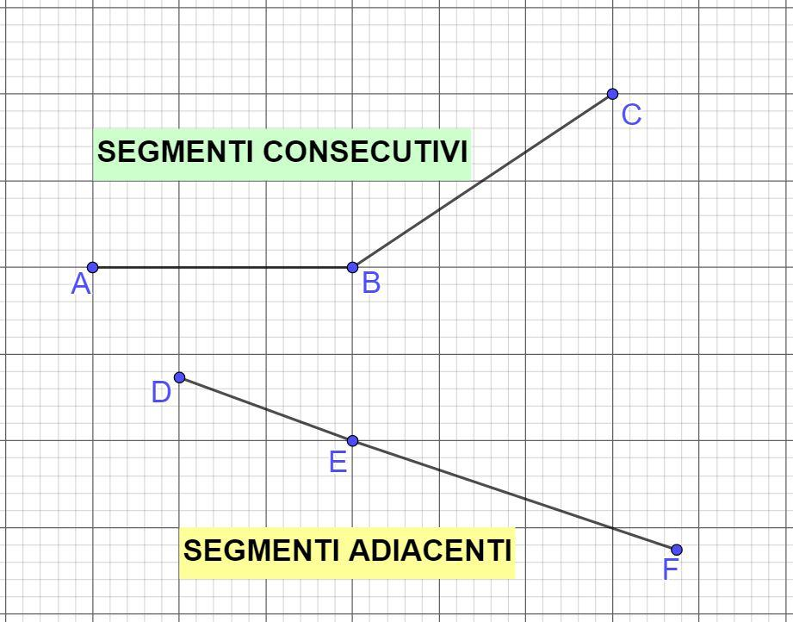
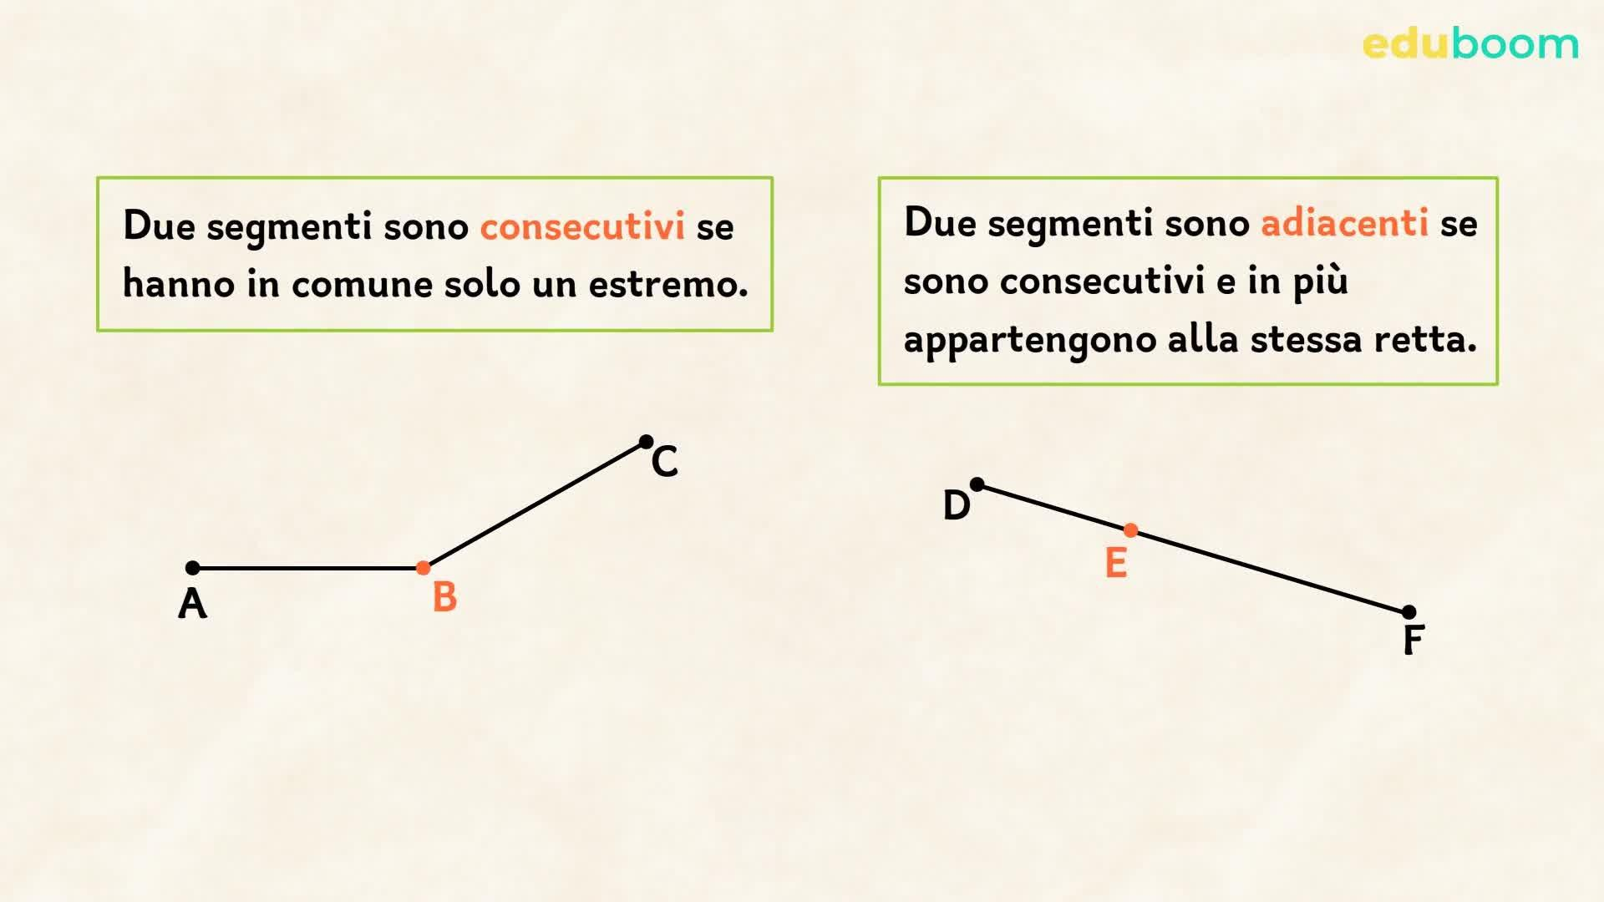

Purpose
# Source: AI Source: Provided by: [Data Path: Persons Table -> ID Column: 1, Name_En Column: Motasem Essam] -> From: [ChatGPT] on [7/25/2026]
Touching collinear segments are used to describe segments that:
- share a common supporting line;
- meet at an endpoint;
- have zero gap;
- do not overlap over a positive length;
- form continuous straight-line paths;
- can be analyzed using the Segment Addition Postulate.

Fundamental Concept
# Source: AI Source: Provided by: [Data Path: Persons Table -> ID Column: 1, Name_En Column: Motasem Essam] -> From: [ChatGPT] on [7/25/2026]
The essential relationship is:
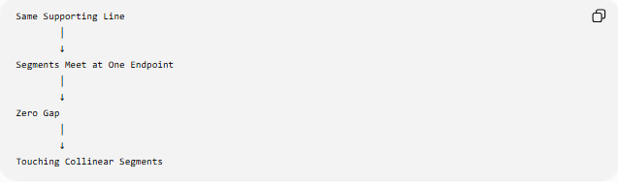
Same Supporting Line
│
↓
Segments Meet at One Endpoint
│
↓
Zero Gap
│
↓
Touching Collinear Segments
Geometrically:
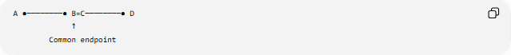
A ●────────● B=C────────● D
↑
Common endpoint
The shared point is simultaneously:
$$B=C$$
for the two segment descriptions.

Mathematical Conditions
# Source: AI Source: Provided by: [Data Path: Persons Table -> ID Column: 1, Name_En Column: Motasem Essam] -> From: [ChatGPT] on [7/25/2026]
For segments $\overset{‾}{AB}$and $\overset{‾}{CD}$, touching collinearity requires:
1. Common supporting line
$$A,B,C,D∈l$$
2. A common endpoint
For example:
$$B=C$$
3. No positive-length overlap
$$\operatorname{length}\left(\overset{‾}{AB}∩\overset{‾}{CD}\right)=0$$
Therefore:
$$\boxed{\overset{‾}{AB}∩\overset{‾}{CD}=\left\{B\right\}}$$
and:
$$\boxed{g=0}$$

Example 1 — Two Adjacent Segments
# Source: AI Source: Provided by: [Data Path: Persons Table -> ID Column: 1, Name_En Column: Motasem Essam] -> From: [ChatGPT] on [7/25/2026]
Consider:
$$A\left(1 , 3\right), B\left(5 , 3\right), C\left(5 , 3\right), D\left(9 , 3\right)$$
The segments are:
$$\overset{‾}{AB}$$
and:
$$\overset{‾}{CD}$$
All points lie on:
$$y=3$$
and:
$$B=C=\left(5 , 3\right)$$
Therefore:
$$\overset{‾}{AB}∩\overset{‾}{CD}=\left\{\left(5 , 3\right)\right\}$$
The segments touch at one endpoint.

Segment Addition
# Source: AI Source: Provided by: [Data Path: Persons Table -> ID Column: 1, Name_En Column: Motasem Essam] -> From: [ChatGPT] on [7/25/2026]
One important consequence of touching collinear segments is that they can form a longer continuous segment.
A ●────────● B=C────────● D
Since $B$lies between $A$and $D$:
$$\boxed{AB+CD=AD}$$
This is an application of the Segment Addition Postulate.
For example, if:
$$AB=4$$
and:
$$CD=6$$
then:
$$AD=4+6=10$$

Interval Representation
# Source: AI Source: Provided by: [Data Path: Persons Table -> ID Column: 1, Name_En Column: Motasem Essam] -> From: [ChatGPT] on [7/25/2026]
Represent the segments as intervals:
$$S_{1}=\left[a , b\right]$$
and:
$$S_{2}=\left[b , d\right]$$
where:
$$a<b<d$$
Then:
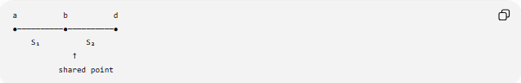
a b d
●──────────●──────────●
S₁ S₂
↑
shared point
Their intersection is:
$$S_{1}∩S_{2}=\left\{b\right\}$$
and their gap is:
$$\boxed{g=0}$$

Touching vs. Separated Collinear Segments
# Source: AI Source: Provided by: [Data Path: Persons Table -> ID Column: 1, Name_En Column: Motasem Essam] -> From: [ChatGPT] on [7/25/2026]
Separated
A ●──────● B C ●──────● D
g>0
$$g>0$$
Touching
A ●──────● B=C──────● D
$$g=0$$
Therefore:
$$\boxed{\text{Separated}⇒g>0} \\ \boxed{\text{Touching}⇒g=0}$$

Touching vs. Overlapping Collinear Segments
# Source: AI Source: Provided by: [Data Path: Persons Table -> ID Column: 1, Name_En Column: Motasem Essam] -> From: [ChatGPT] on [7/25/2026]
This distinction is important.
Touching
A ●────────● B=C────────● D
The intersection contains only one point:
$$\overset{‾}{AB}∩\overset{‾}{CD}=\left\{B\right\}$$
Overlapping
A ●────────────────● D
B ●────● C
The intersection contains a segment of positive length:
$$length⁡\left(AB∩CD\right)>0$$
Therefore:
$$\boxed{\text{Touching}≠\text{Overlapping}}$$
even though both have zero minimum gap.

Touching vs. Coincident Collinear Segments
# Source: AI Source: Provided by: [Data Path: Persons Table -> ID Column: 1, Name_En Column: Motasem Essam] -> From: [ChatGPT] on [7/25/2026]
Touching
The segments share only a boundary point:
$$length⁡\left(S_{1}∩S_{2}\right)=0$$
Coincident
The segments occupy exactly the same set of points:
$$S_{1}=S_{2}$$
Thus:
$$\boxed{\text{Coincident segments are not merely touching}}$$

Types of Touching Arrangements
# Source: AI Source: Provided by: [Data Path: Persons Table -> ID Column: 1, Name_En Column: Motasem Essam] -> From: [ChatGPT] on [7/25/2026]
For two collinear segments, the standard touching arrangement is endpoint-to-endpoint contact:
A ●────────● B=C────────● D
There can also be multiple segments meeting at the same point:
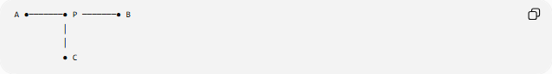
A ●───────● P ───────● B
│
│
● C
Here several geometric objects may share the same point $P$, but when discussing two collinear segments, the standard case is one shared endpoint.

Geometric Interpretation
# Source: AI Source: Provided by: [Data Path: Persons Table -> ID Column: 1, Name_En Column: Motasem Essam] -> From: [ChatGPT] on [7/25/2026]
Touching collinear segments can be understood as the boundary case between separation and overlap.
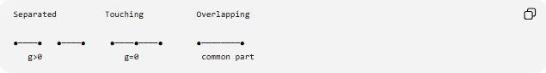
Separated Touching Overlapping

●────● ●────● ●────●────● ●────────●
g>0 g=0 common part
As the gap decreases:
$$g>0$$
then:
$$g=0$$
the segments touch.
If they move farther into each other, they become overlapping.

Relationship to Contact
# Source: AI Source: Provided by: [Data Path: Persons Table -> ID Column: 1, Name_En Column: Motasem Essam] -> From: [ChatGPT] on [7/25/2026]
Touching collinear segments are a special case of geometric contact.
Their intersection is:
$$\overset{‾}{AB}∩\overset{‾}{CD}=\left\{P\right\}$$
where $P$is their common endpoint.
Thus:
$$\boxed{\text{Touching Collinear Segments}⊆\text{Contact}}$$
while simultaneously:
$$\boxed{\text{Touching Collinear Segments}⊆\text{Segment Collinearity}}$$
This makes the concept an intersection of two properties:
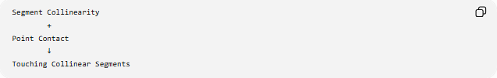
Segment Collinearity
+
Point Contact
↓
Touching Collinear Segments

Important Properties
# Source: AI Source: Provided by: [Data Path: Persons Table -> ID Column: 1, Name_En Column: Motasem Essam] -> From: [ChatGPT] on [7/25/2026]
- The segments lie on the same supporting straight line.
- They share at least one endpoint.
- In the standard two-segment case, they share exactly one point.
- Their minimum gap is zero:
$$g=0$$
- They do not overlap over a positive length.
- They can form one continuous longer segment.
- Segment lengths can be added when one segment follows the other.
- They represent a boundary case between separation and overlap.
- They are both collinear and in contact.
- Touching does not mean that the two segments are coincident.

Comparison
# Source: AI Source: Provided by: [Data Path: Persons Table -> ID Column: 1, Name_En Column: Motasem Essam] -> From: [ChatGPT] on [7/25/2026]
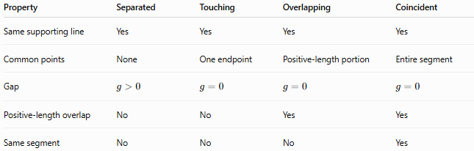
Property | Separated | Touching | Overlapping | Coincident
Same supporting line | Yes | Yes | Yes | Yes
Common points | None | One endpoint | Positive-length portion | Entire segment
Gap | $$g>0$$ | $$g=0$$ | $$g=0$$ | $$g=0$$
Positive-length overlap | No | No | Yes | Yes
Same segment | No | No | No | Yes

Key Points
# Source: AI Source: Provided by: [Data Path: Persons Table -> ID Column: 1, Name_En Column: Motasem Essam] -> From: [ChatGPT] on [7/25/2026]
- Touching Collinear Segments lie on the same straight line.
- They meet at a common endpoint.
- Their minimum gap is:
$$g=0$$
- They do not share a segment of positive length.
- If $B=C$, then:
$$\overset{‾}{AB}∩\overset{‾}{CD}=\left\{B\right\}$$
- Adjacent touching segments can be combined using:
$$AB+CD=AD$$
- They differ from separated segments by having zero rather than positive gap.
- They differ from overlapping segments because their common set contains only a point.
- They differ from coincident segments because they do not occupy the same entire set of points.

Conclusion
# Source: AI Source: Provided by: [Data Path: Persons Table -> ID Column: 1, Name_En Column: Motasem Essam] -> From: [ChatGPT] on [7/25/2026]
Touching Collinear Segments are collinear line segments that meet at a common endpoint without overlapping over a positive length. They represent the zero-gap case of segment collinearity and are closely related to point contact and the Segment Addition Postulate.

